SEKA KAMA
A DIGITAL TWIN PLATFORM FOR EAST AFRICAN LION CONSERVATION IN THE GREATER MARA ECOSYSTEM
SYSTEM DOCUMENTATION

BY
JAMES MWAURA
REGISTRATION NUMBER: DSE-02-0143/2025

A system documentation submitted in partial fulfilment of the requirements for the award of the Diploma in Software Engineering
School of Media, ICT and Engineering
Department of Information Communication and Technology
Zetech University

SEPTEMBER 2026

DECLARATION
I declare that this project documentation is my original work and has not been submitted for assessment in another institution. Work by other authors will be acknowledged through appropriate citation.
Student: James Mwaura Registration No.: DSE-02-0143/2025
Signature: ______________________________ Date: __________________
Supervisor: _____________________________ Date: __________________

DEDICATION
This page may be completed by the student at the final documentation milestone.

ACKNOWLEDGEMENT
This page will be completed after project supervision and development activities have concluded.

ABSTRACT
This project will specify, design, develop and evaluate a proposed geospatial decision-support platform for East African lion conservation in the Greater Mara ecosystem. It responds to the need to bring ecological indicators, spatial evidence and scenario analysis into a usable planning workflow. Authorised planners and researchers will be able to select an area, define a land-use or habitat scenario, compare modelled results with baseline conditions and inspect mapped and numerical outputs. Work will commence on 12 September 2026 and follow the six milestones in the Zetech University Project Supervision Form: planning and analysis; interface and logic design; two stages of development and testing; deployment; and final documentation. The proposed design will draw on a web interface, API services, spatial data and an XGBoost prediction service. Evaluation will cover functional behaviour, model and data limitations, performance, security and user acceptance. Predictions will serve as decision-support evidence for review alongside field observations and professional judgement.

DEFINITION OF KEY TERMS
Term | Definition
Digital twin | A computational representation of a real-world system connected to data for examining current states or scenarios.
Geospatial intelligence | Actionable information derived from location-based data and analysis.
Greater Mara | The Maasai Mara National Reserve and neighbouring conservancies within the study boundary.
XGBoost | A gradient-boosted decision-tree method proposed for ecological prediction.
PostGIS | A PostgreSQL extension for storing and querying geographic data.
Scenario | A set of proposed feature changes applied to a selected area for comparison with a baseline.
Baseline | The reference data and model output used for scenario comparison.
Human-wildlife conflict | Interactions between people and wildlife that cause or risk harm to people, livestock, property or wildlife.

ABBREVIATIONS AND ACRONYMS
Acronym | Meaning
AI | Artificial Intelligence
API | Application Programming Interface
DSR | Design Science Research
ERD | Entity-Relationship Diagram
GIS | Geographic Information System
GPS | Global Positioning System
IoT | Internet of Things
KWS | Kenya Wildlife Service
ML | Machine Learning
NDVI | Normalized Difference Vegetation Index
REST | Representational State Transfer
SDLC | Software Development Life Cycle
UAT | User Acceptance Testing
VIIRS | Visible Infrared Imaging Radiometer Suite
WDPA | World Database on Protected Areas
XGBoost | Extreme Gradient Boosting

TABLE OF CONTENTS
The following outline follows the supplied system-documentation sample and supervision milestones. Refresh page references in Word after final pagination.
CHAPTER ONE: PROJECT PLANNING AND ANALYSIS
1.1 Statement of Problem | 1.2 Study Justification | 1.3 System Objectives
1.4 Functional Requirements | 1.5 Non-Functional Requirements
1.6 Scope and Delimitation | 1.7 Tools and Resources | 1.8 Schedule
CHAPTER TWO: PROJECT DESIGN
2.1 Proposed System | 2.2 Users and Roles | 2.3 Interface Design
2.4 Architecture and Logic | 2.5 Data Flow | 2.6 ER Design
2.7 Scenario Processing and Sample Code | 2.8 Data Quality and Security
CHAPTER THREE: DEVELOPMENT, TESTING AND DEPLOYMENT
3.1 Development Plan | 3.2 Data and Database | 3.3 Feature Plan
3.4 Testing Plan | 3.5 Deployment Plan | 3.6 Maintenance
CHAPTER FOUR: CONCLUSIONS AND RECOMMENDATIONS
REFERENCES | APPENDICES

LIST OF FIGURES
- Figure 2.1 Conservation visual reference
- Figure 2.2 Proposed map workspace reference
- Figure 2.3 Platform context diagram
- Figure 2.4 Level-one data-flow diagram
- Figure 2.5 Entity-relationship design

LIST OF TABLES
- Table 1.1 Functional requirements
- Table 1.2 Non-functional requirements
- Table 1.3 Tools and resources
- Table 1.4 Schedule
- Table 2.1 User roles
- Table 2.2 Core entities
- Table 3.1 Development plan
- Table 3.2 Testing plan
- Table 3.3 Deployment activities

CHAPTER ONE: PROJECT PLANNING AND ANALYSIS
This chapter establishes the problem, purpose, scope, requirements, resources and schedule for the proposed Seka Kama platform. Work will commence on 12 September 2026. The milestone sequence follows the Zetech University Project Supervision Form.

1.1 Statement of Problem
Lion conservation in the Greater Mara depends on timely information about habitat conditions, human activity and conflict risk. Field observations, incident records, satellite products and spatial datasets may be held in different formats and reviewed at different times. This fragmentation can make it difficult for planners to examine how a proposed land-use change could affect ecological conditions across a selected area. The proposed project will address this planning gap through a geospatial workflow that combines baseline indicators and scenario analysis. Users will identify a geography, specify a change and review a modelled comparison with its assumptions and limitations. The result will inform, rather than replace, field evidence and professional judgement.

1.2 Study Justification
A spatial scenario workflow is justified because conservation and land-use decisions are place-specific and involve interacting indicators. A digital-twin approach can connect reference layers, modelling and map-based review. The project will examine how a web workspace and geospatial services could support repeatable analysis for conservation planners and researchers. Satellite telemetry and nightlight trends are intended sources in the proposal; their access, permissions, temporal coverage and integration will be confirmed during requirements analysis.

1.3 System Objectives

1.3.1 General Objective
To design, develop and evaluate a geospatial decision-support platform for scenario-based monitoring and conservation planning for East African lions in the Greater Mara ecosystem.

1.3.2 Specific Objectives
- Design a geospatial workspace that will bring approved ecological and spatial indicators together for the study area.
- Develop a scenario workflow that will allow authorised users to define a geography and proposed feature changes, then compare modelled results with baseline conditions.
- Design map, summary and explanation outputs that will help users interpret scenario results and assumptions.
- Evaluate the platform through functional, performance, security and user-acceptance activities aligned with the project milestones.

1.3.3 Research Questions
- How will selected ecological and spatial sources be integrated into a unified workflow for the Greater Mara?
- How will scenario analysis support review of potential habitat and human-wildlife pressures?
- To what extent will the proposed platform meet functional, performance, security and user needs?

1.3.4 Working Hypothesis
The proposed platform is expected to make scenario comparison more structured and accessible than reviewing disconnected spatial layers and records. Evaluation will examine this expectation; it is not presented as a measured result.

1.4 Functional Requirements
ID | Requirement
FR1 | Provide authenticated access for authorised users.
FR2 | Display a baseline map with filters for available management units.
FR3 | Allow an area of interest to be drawn or supplied as supported GeoJSON.
FR4 | Allow a user to define supported feature modifications for a scenario.
FR5 | Identify relevant grid cells and retrieve baseline features for the selected area.
FR6 | Estimate scenario outcomes and compare them with baseline values.
FR7 | Present affected geography, summary values and a plain-language interpretation.
FR8 | Retain scenario metadata and allow review of prior scenario runs.
FR9 | Allow authorised users to export appropriate map or summary material.
FR10 | Support controlled user access and review of significant activity.

1.5 Non-Functional Requirements
Area | Proposed requirement
Usability | Clear labels, map cues and readable explanations for non-technical conservation users.
Performance | Measure spatial queries and scenario runs against agreed test data and acceptance thresholds.
Security | Use authentication, roles, secure secret handling and input validation.
Reliability | Report data or prediction errors clearly; never present failed requests as valid results.
Data quality | Check geometry, attributes, coordinate systems and feature ranges.
Maintainability | Separate interface, API, prediction and data access responsibilities.
Accessibility | Support readable contrast, keyboard use for core controls and text alternatives.
Traceability | Retain scenario inputs, model version and processing metadata where permitted.

1.6 Scope and Delimitation
The study will focus on the Maasai Mara National Reserve and neighbouring conservancies within the defined Greater Mara study boundary, and on the East African lion. The platform will support baseline mapping, scenario definition, spatial feature selection, model comparison, result interpretation and export. Intended sources include approved satellite, land-cover, terrain, nightlight and protected-area data, and suitable conservation records when access is authorized. The project will not establish field truth for every ecological condition, guarantee real-time sensor availability or automate management decisions. Live telemetry and IoT integrations will be included only if access and technical feasibility are confirmed. Outputs will be estimates subject to data coverage and validation.

1.7 Tools and Resources
Resource | Proposed use
React/Next.js web interface | Map workspace, scenario inputs, dashboard and results.
Python/FastAPI services | Authentication, validation, spatial requests and scenario orchestration.
PostgreSQL/PostGIS or approved hosted equivalent | Store and query grid cells, protected areas and scenario metadata.
XGBoost, scikit-learn and NumPy | Prepare features and generate ecological estimates, after verification.
Mapping libraries | Display boundaries, scenario areas and comparison layers.
Visual Studio Code and Git | Source editing, version tracking and review.
Browser devices and test environment | Functional and usability evaluation on laptop and desktop browsers.
People | Student developer, supervisor, domain reviewers and selected test users, subject to availability.

1.8 Project Schedule Breakdown
The schedule begins 12 September 2026. Later dates are proposed estimates and may be adjusted with the supervisor. Scoring, meeting date and signature fields in the supervision form remain for supervisor review.
Milestone | Planned period | Activities and documentation
1. Planning and analysis | 12-25 Sep 2026 | Problem, justification, objectives, tools/resources, schedule, cover and Chapter One.
2. Project design | 26 Sep-9 Oct 2026 | Identify and sketch user screens; design component logic, flowcharts, UML and ERD; Chapter Two.
3. Development and testing (1/2) | 10-31 Oct 2026 | Begin feature-by-feature implementation and debugging; database development; Chapter Three progress.
4. Development and testing (2/2) | 1-20 Nov 2026 | Continue and integrate features; resolve defects; evaluate workflows; update Chapter Three.
5. Deployment | 21 Nov-5 Dec 2026 | Prepare simulated or approved environment, configure services and verify deployment; document Chapter Three.
6. Final documentation | 6-18 Dec 2026 | Complete preliminary pages, Chapter Four, recommendations, APA 7 references and final review.

CHAPTER TWO: PROJECT DESIGN
This chapter presents the proposed screens, architecture, data flow, database structure and scenario logic. Diagrams are design artefacts for Milestone 2 and describe how development is intended to proceed from 12 September 2026; they do not assert completed operation.

2.1 Overview of the Proposed System
The platform will connect a browser-based conservation workspace to an API, spatial data store and prediction service. A user will select an area, inspect available baseline indicators and submit a scenario. The API will validate the request, retrieve relevant features, prepare model inputs and return a result for map and summary presentation. The user will be able to review assumptions and compare a scenario with baseline conditions. The proposed technical baseline will use a React/Next.js interface, Python API services, spatial database access and an XGBoost prediction model. Final versions, schemas and hosting choices will be confirmed during project work.

2.2 Users and Roles
User group | Responsibilities | Functions
Conservation planner | Frame a planning question and compare changes. | Area selection, scenario, maps, summaries and exports.
Researcher or analyst | Review indicators, assumptions and trends. | Feature summaries, history and model context.
Data steward | Prepare and validate approved layers. | Data checks, controlled updates and metadata.
Administrator | Manage access and oversee activity. | Roles, access controls and activity review.

2.3 Proposed User Interface Design
The map-first workspace will combine the map with a scenario panel, management-unit filters, feature-change inputs and result summaries. A sign-in screen will provide the entry point. A history/reports view will support review of saved scenarios, and settings will support authorised account management. Screen labels and control placement will be validated with prospective users during design review.

Figure 2.1 Proposed visual reference for the platform identity and conservation context.
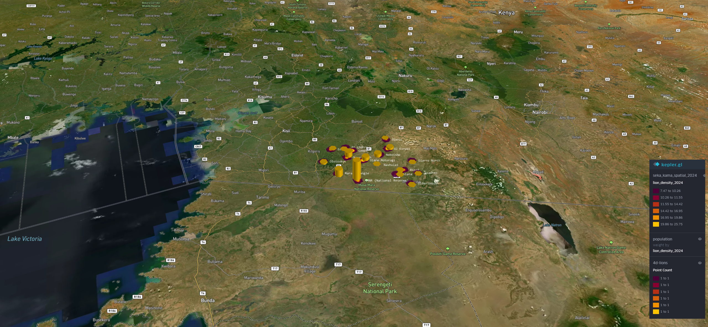
Figure 2.2 Proposed map-workspace reference; screen content will be adapted to the approved study workflow.

2.4 Architecture and Logic Design
The presentation layer will provide maps and forms. The API layer will validate requests and orchestrate data access. The spatial layer will store and query geographic evidence. The prediction layer will prepare features and estimate scenario outcomes. Approved external sources will enter through a documented ingestion process. Results will return with context for interpretation.
Layer | Proposed responsibility
Presentation | Sign-in, map, scenario form, results, history and export controls.
API/application logic | Authentication, validation, orchestration, audit metadata and response formatting.
Spatial data | Grid cells, study boundaries, protected areas, management units and spatial indexes.
Prediction | Feature preparation, inference, baseline comparison and limitations.
External data | Approved satellite, land-cover, terrain, nightlight and conservation data.

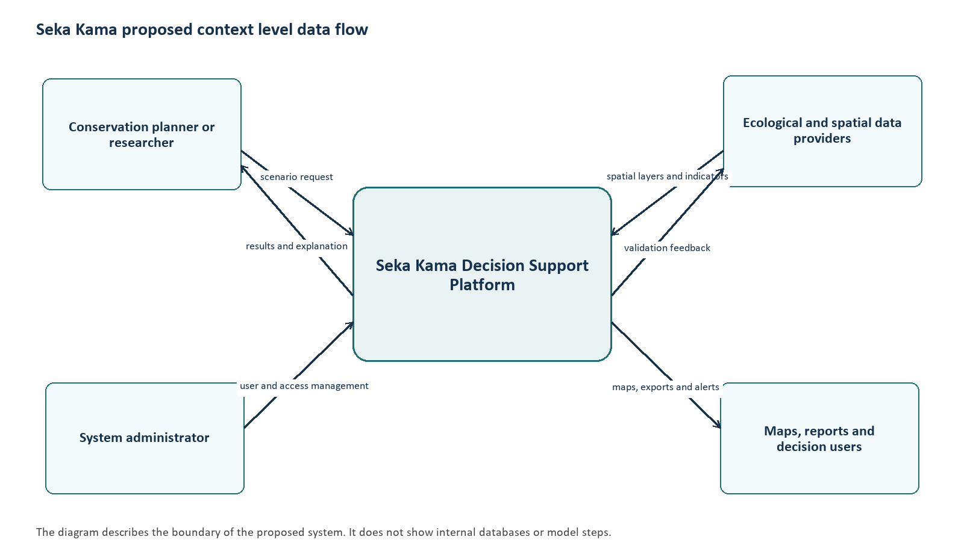
Figure 2.3 Proposed platform context diagram.
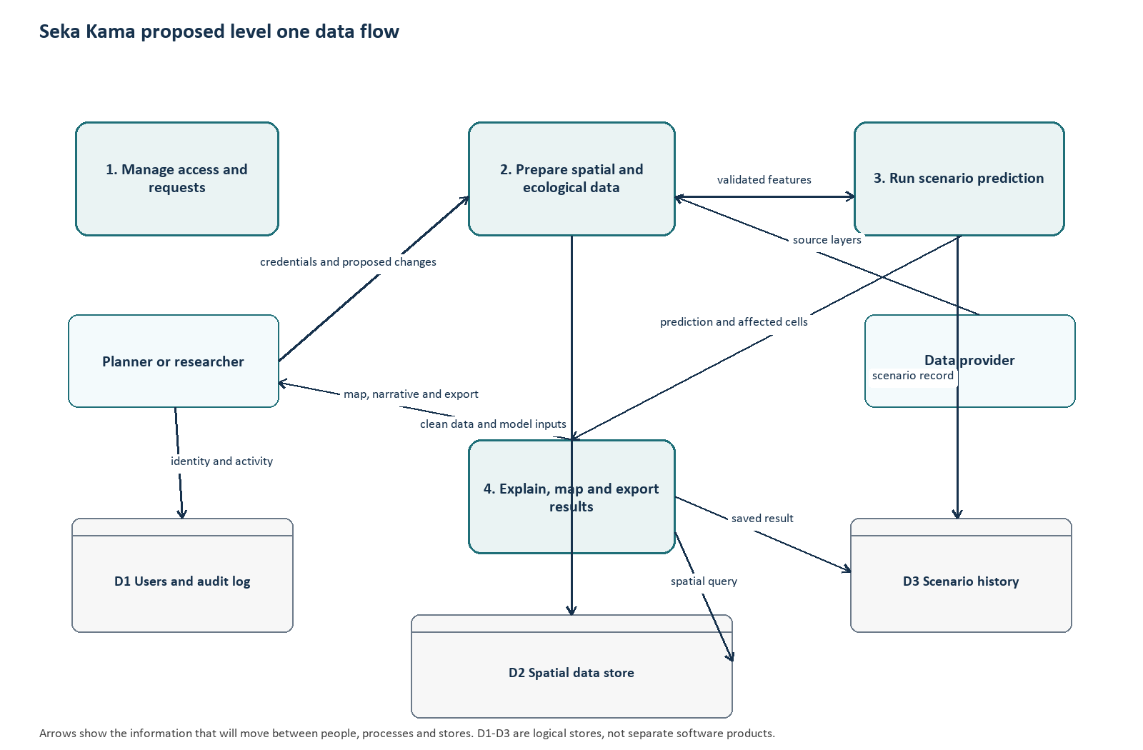
Figure 2.4 Proposed level-one data-flow diagram.

2.5 Data Flow
A scenario request will be checked for authentication, valid geometry and supported changes. The spatial service will identify intersecting analysis cells and retrieve baseline features. The preparation step will create model-ready values without changing reference records. The prediction service will calculate a scenario estimate, compare it with the baseline and prepare a map, summary and explanation. Saved records will retain only information needed for review and audit, subject to the approved data policy.

2.6 Entity-Relationship Design
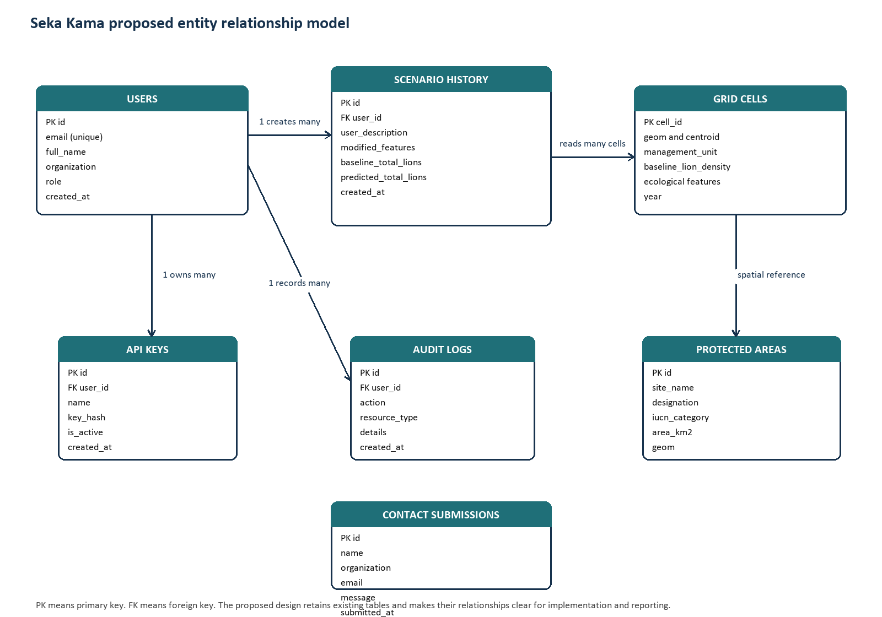
Figure 2.5 Proposed entity-relationship design for platform records.
Entity | Purpose and relationship
Users | Identity, organization, role and access status; associated with keys, scenarios and audit entries.
Grid cells | Geometry and baseline features; many cells can be selected by a scenario.
Scenario history | Inputs, selected area, baseline and predicted summaries; owned by a user.
Protected areas | Conservation boundaries for comparison with grid cells.
Audit logs | Significant access and platform actions associated with an actor where available.
API keys | Programmatic credentials associated with a user and stored securely.

2.7 Scenario Processing and Proposed Sample Code
The illustrative sample shows the intended pattern: validate a request, retrieve affected baseline features, apply permitted changes to a copy, predict and compare. Before implementation, schemas, feature names, units, authorization, error handling and model inputs will be verified.
# Proposed sample: illustrative scenario service
def run_scenario(request, spatial_store, predictor):
area = validate_geojson(request.geometry)
changes = validate_feature_changes(request.feature_modifications)
cells = spatial_store.cells_intersecting(area, request.management_units)
if not cells:
raise ValueError("No cells intersect the selected area")
baseline = spatial_store.features_for(cells)
scenario = baseline.copy(deep=True)
for name, change in changes.items():
scenario[name] = scenario[name] * (1 + change)
estimate = predictor.predict(scenario)
base_total = float(baseline["baseline_lion_density"].sum())
scenario_total = float(estimate.sum())
return {"baseline": base_total, "scenario": scenario_total,
"change": scenario_total - base_total,
"cells": len(cells), "assumptions": changes}
The workflow will not overwrite baseline data. A saved response will include scenario and model metadata once the retention design is approved. Explanations will distinguish estimates from observed events.

2.8 Data Quality, Privacy and Security
- Validate GeoJSON, geographic bounds and permitted feature names before processing.
- Use consistent coordinate reference systems; check topology, attributes and provenance during ingestion.
- Keep baseline data read-only to scenario operations; store changes with scenario records.
- Apply role-based authorization to protected data, exports and administration.
- Keep credentials outside source code and use established password hashing.
- Document sources, model versions, feature units and known limitations.
- Restrict precise wildlife locations and sensitive incident information to approved roles.
- Record significant access and administrative activity under the approved data policy.

2.9 Chapter Summary
The design will connect a map-based workflow to spatial queries and model inference through an API. The diagrams, entity model and sample logic will guide interface, database and feature development during the next milestones.

CHAPTER THREE: PROJECT DEVELOPMENT, TESTING AND DEPLOYMENT
This chapter defines the planned implementation and evaluation. Development will begin on 12 September 2026, with feature work following design review. Outcomes and supervisor assessments will be added as milestone work is completed.

3.1 Development Plan
The project will use a staged SDLC consistent with the supervision form. Requirements and design will be reviewed before implementation. Interface, API, spatial structures and model workflow will be developed feature by feature, followed by debugging and integration. Design Science Research will guide creation and evaluation of the decision-support artefact.

3.2 Data and Database Development
The database design will cover users, spatial grid cells, protected areas, management units, scenario history and audit metadata. Geometry columns and spatial indexes will support intersection queries. Ingestion will record source, date, coordinate system and transformations. Model integration will verify feature names, units, ordering and missing-value handling against the approved data dictionary.

3.3 Feature Development Plan
Feature | Planned implementation | Review evidence
Access and roles | Authentication flow, protected routes and account controls. | Role and access checks.
Baseline map | Load approved layers, filters and legends. | Map/source metadata review.
Scenario input | Collect geometry, units and supported changes. | Validation and interaction records.
Spatial selection | Query cells intersecting valid geometry. | Known-area query examples.
Prediction/comparison | Prepare features, infer and compare baseline. | Reproducible inputs and outputs.
History/export | Save scenario metadata and create permitted exports. | Record and export inspection.
Administration | Manage roles and review activity. | Role-specific workflow review.

3.4 Testing Plan
Testing will occur during feature work and after integration. Acceptance measures will be agreed during design review. Test data will be non-sensitive or appropriately authorized.
Level | Planned focus | Evidence
Unit/component | Validation, feature calculations, response formatting and permissions. | Input/output records and defect log.
Integration | Interface/API, API/spatial store and prediction connections. | Request traces and comparison checks.
Functional/system | Requirements FR1-FR10 and complete scenario workflow. | Requirement-to-test matrix.
Performance | Map loading and scenario response under agreed volume. | Timings and test environment.
Security | Authentication, roles, input handling and secret configuration. | Access review findings.
User acceptance | Task completion and clarity feedback from selected users. | Consent-aware feedback summary.

3.4.1 Acceptance Measures
- Each functional requirement will have a recorded test case before final evaluation.
- Malformed geometry or unsupported input will be rejected with a clear message.
- Baseline records will remain unchanged after scenario processing.
- Repeated runs with identical data, model and inputs will meet an agreed numerical tolerance.
- Performance thresholds will be agreed with the supervisor and documented with the environment.
- Usability feedback will be summarized without overstating the sample.

3.5 Deployment Plan
At Milestone 5, the application will be prepared for a simulated or approved hosting environment. Configuration will cover service URLs, database access, model files, credentials and roles. Health checks and core workflows will be verified. The hosting choice will consider cost, availability, data sensitivity and institutional approval. Public release or live conservation feeds will require authorization.
Activity | Planned result
Environment preparation | Document runtime, dependencies and configuration.
Secure configuration | Keep secrets outside source; apply roles and database permissions.
Release checks | Verify core screens, baseline access and a sample scenario.
Operational notes | Document backup, monitoring, limitations and rollback steps.
Supervisor review | Present evidence and Chapter Three record for assessment.

3.6 Maintenance Considerations
Future maintenance will include dependency updates, source refreshes, model revalidation and access-control review. Changes to model features or spatial schemas will require corresponding updates to the data dictionary, tests and user documentation.

CHAPTER FOUR: CONCLUSIONS AND RECOMMENDATIONS
This chapter sets out conclusions and recommendations to be finalized after implementation, testing and deployment review. It is prospective and will be updated using evidence from the supervision milestones.

4.1 Conclusion
The project will design and evaluate a geospatial decision-support platform for reviewing conservation scenarios in the Greater Mara. Its planned contribution is a workflow that links an area of interest, approved baseline evidence, modelled comparison and readable outputs. The platform will be useful only to the extent that data and model behaviour are validated and communicated. Final conclusions will be based on recorded evaluation evidence after the milestones are completed.

4.2 Recommendations
- Confirm data access, licensing, provenance and update frequency before implementation.
- Agree on ecological interpretation and model evaluation measures with qualified practitioners.
- Keep predicted values separate from observed incident records; show data dates, model version and limitations.
- Protect precise wildlife locations and sensitive community or incident information.
- Conduct user-acceptance review with representative conservation and technical users before operational adoption.
- Treat live sensor integration as a later extension unless access and governance are established within scope.

4.3 Areas for Further Work
Further work may examine additional species, longer time series, validated field observations, uncertainty visualization, mobile reporting and authorized sensor integrations. Each extension will require independent data, privacy and model validation.

REFERENCES
Bauer, H., Chapron, G., Nowell, K., Henschel, P., Funston, P., Hunter, L. T. B., Macdonald, D. W., & Packer, C. (2015). Lion (Panthera leo) populations are declining rapidly across Africa, except in intensively managed areas. Proceedings of the National Academy of Sciences, 112(48), 14894-14899. https://doi.org/10.1073/pnas.1500664112
Chen, T., & Guestrin, C. (2016). XGBoost: A scalable tree boosting system. In Proceedings of the 22nd ACM SIGKDD International Conference on Knowledge Discovery and Data Mining (pp. 785-794). ACM. https://doi.org/10.1145/2939672.2939785
Grieves, M., & Vickers, J. (2017). Digital twin: Mitigating unpredictable, undesirable emergent behavior in complex systems. In F.-J. Kahlen, S. Flumerfelt, & A. Alves (Eds.), Transdisciplinary perspectives on complex systems (pp. 85-113). Springer. https://doi.org/10.1007/978-3-319-38756-7_4
Hämäläinen, M. (2020). Smart city development with digital twin technology. In Proceedings of the 33rd Bled eConference (pp. 1-15). University of Maribor Press. https://doi.org/10.18690/978-961-286-362-3.7
Hevner, A. R., March, S. T., Park, J., & Ram, S. (2004). Design science in information systems research. MIS Quarterly, 28(1), 75-105. https://doi.org/10.2307/25148625
International Union for Conservation of Nature. (2021). Panthera leo (errata version published in 2021). The IUCN Red List of Threatened Species 2021: e.T15951A215765030. https://doi.org/10.2305/IUCN.UK.2021-1.RLTS.T15951A215765030.en
Nikkhah, A., Rezapour, S., & Emadi, M. (2021). Applications of smart sensors and IoT in precision agriculture: A review. Journal of Agricultural Science and Technology, 23(1), 1-12.
Peffers, K., Tuunanen, T., Rothenberger, M. A., & Chatterjee, S. (2007). A design science research methodology for information systems research. Journal of Management Information Systems, 24(3), 45-77. https://doi.org/10.2753/MIS0742-1222240302
Pettorelli, N., Laurance, W. F., O’Brien, T. G., Wegmann, M., Nagendra, H., & Turner, W. (2014). Satellite remote sensing for applied ecologists: Opportunities and challenges. Journal of Applied Ecology, 51(4), 839-848. https://doi.org/10.1111/1365-2664.12261
United Nations Environment Programme World Conservation Monitoring Centre. (2023). World Database on Protected Areas (WDPA). https://www.protectedplanet.net
Zetech University. (n.d.). Project supervision form (F-7-53, Issue/Rev. 1/0).

APPENDIX A: PROPOSED SCREEN INVENTORY
Screen | Main elements | User task
Sign-in | Credentials and access notice. | Enter workspace.
Analysis dashboard | Map, legend, filters, scenario panel and baseline summary. | Review conditions and choose an area.
Scenario configuration | Geometry, management unit, changes and description. | Define a reproducible scenario.
Scenario results | Map, comparison, explanation and export. | Interpret and retain decision material.
History and reports | Saved scenarios, dates, filters and exports. | Review prior work.
Administration | Roles, access settings and activity records. | Maintain controlled access.

APPENDIX B: ILLUSTRATIVE SCENARIO REQUEST
{
"geometry": {"type": "Polygon", "coordinates": []},
"feature_modifications": {"ndvi_mean": -0.08},
"management_units": ["approved-unit-id"],
"description": "Illustrative habitat-change scenario"
}
The geometry and feature values are illustrative only; the final schema and supported variables will be confirmed against approved data and model requirements.

